

Practices for Secure Software Report

Table of Contents
Document Revision History 3
Client 3
Instructions 3
Developer 4
1. Algorithm Cipher 4
2. Certificate Generation 4
3. Deploy Cipher 4
4. Secure Communications 4
5. Secondary Testing 4
6. Functional Testing 4
7. Summary 4
8. Industry Standard Best Practices 4

Document Revision History

Version | Date | Author | Comments
1.0 | 10/16/26 | Collin Owens

Client



Instructions

Submit this completed practices for secure software report. Replace the bracketed text with the relevant information. You must document your process for writing secure communications and refactoring code that complies with software security testing protocols.

- Respond to the steps outlined below and include your findings.
- Respond using your own words. You may also choose to include images or supporting materials. If you include them, make certain to insert them in all the relevant locations in the document.
- Refer to the Project Two Guidelines and Rubric for more detailed instructions about each section of the template.

Developer
Collin Owens

Algorithm Cipher

The Advanced Encryption Standard with a 256-bit key (AES-256) is what I would recommend. This algorithm cipher is required by NIST to be used to protect classified data. Before AES was the standard, DES was the standard. It was eventually determined weak because it was a 56-bit key that nowadays can be cracked in less than a day with modern computers. Using AES-256 is considered the “gold standard” due to its extreme level of security. AES-256 uses a 256 bit key that is used to scramble and unscramble the data. The number of combinations that the key can have is tremendous making it uncrackable by brute force attacks. The hash functions are still needed even though the data is being scrambled by the ciphers. The hash functions allow for data integrity making it easy to verify the archive files are not altered or corrupted. The Secure Hash Algorithm 2 (SHA-256) should be used. This will help alert the system of data tampering if a malicious actor alters anything during data transfer.
The symmetric keys use the same key to encrypt and decrypt data. This keeps it fast and a good choice for encrypting large volumes of data. Asymmetric keys use a public key to encrypt and a private key to decrypt. This is used to safely share the symmetric key. Random numbers must be used to generate unpredictable cryptographic keys. If the random numbers are predictable then the attackers can reverse-engineer, the keys.

Certificate Generation
Insert a screenshot below of the CER file.

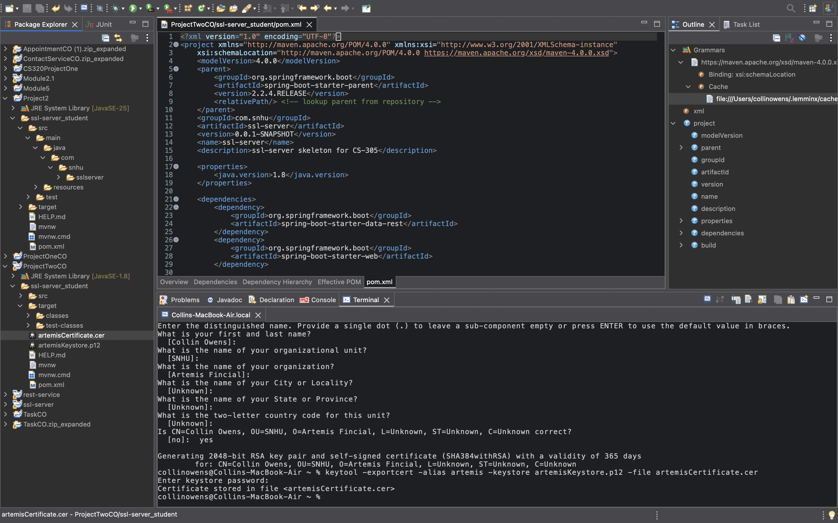

Deploy Cipher
Insert a screenshot below of the checksum verification.

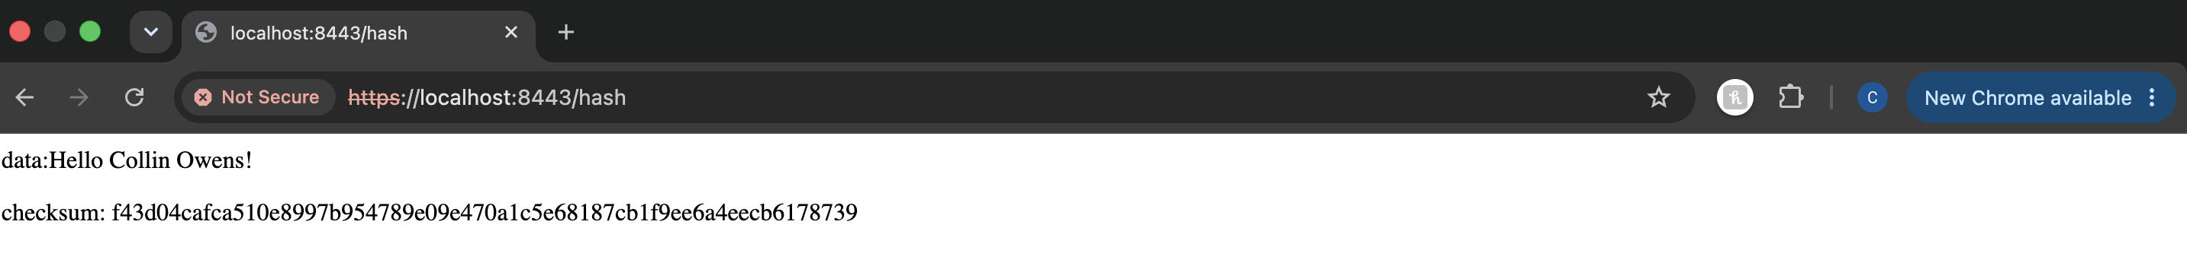

Secure Communications
Insert a screenshot below of the web browser that shows a secure webpage.

Secondary Testing
Insert screenshots below of the refactored code executed without errors and the dependency-check report.
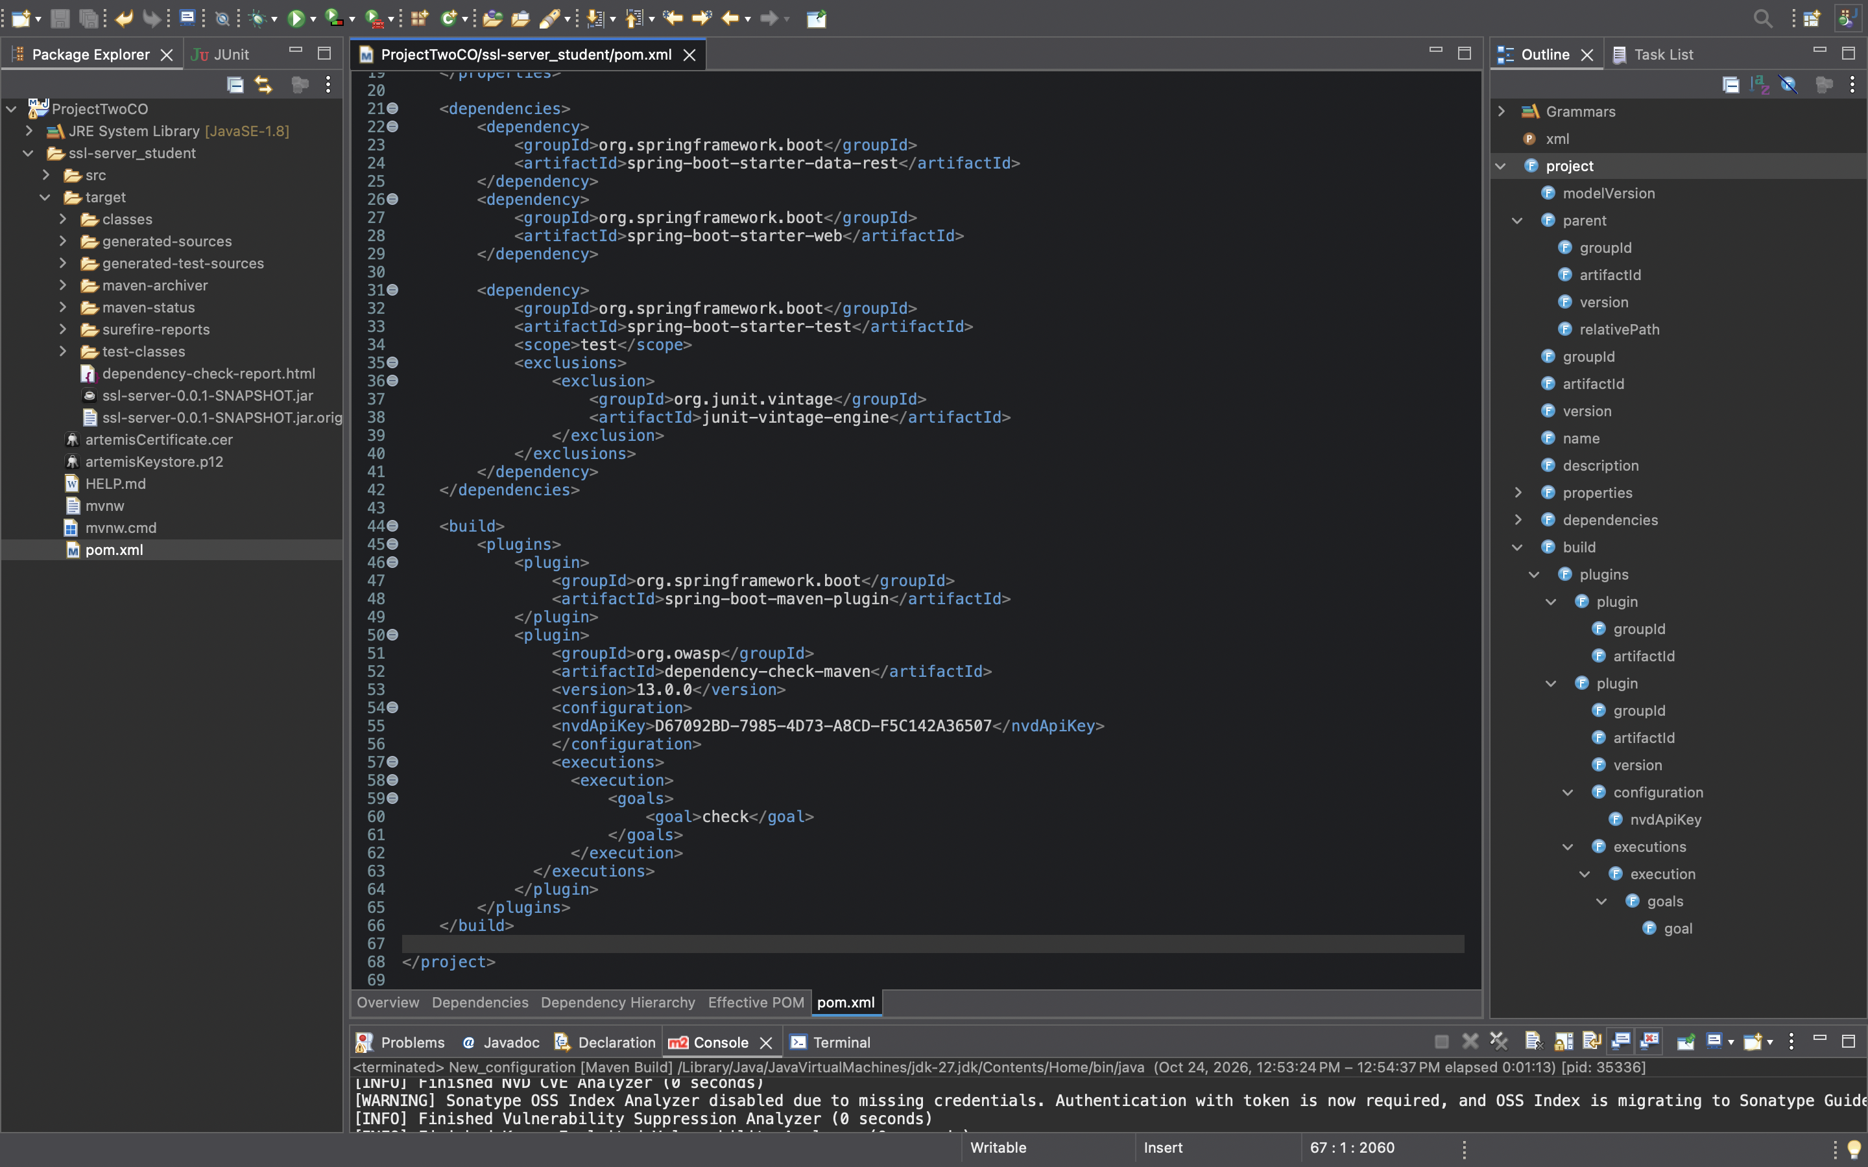
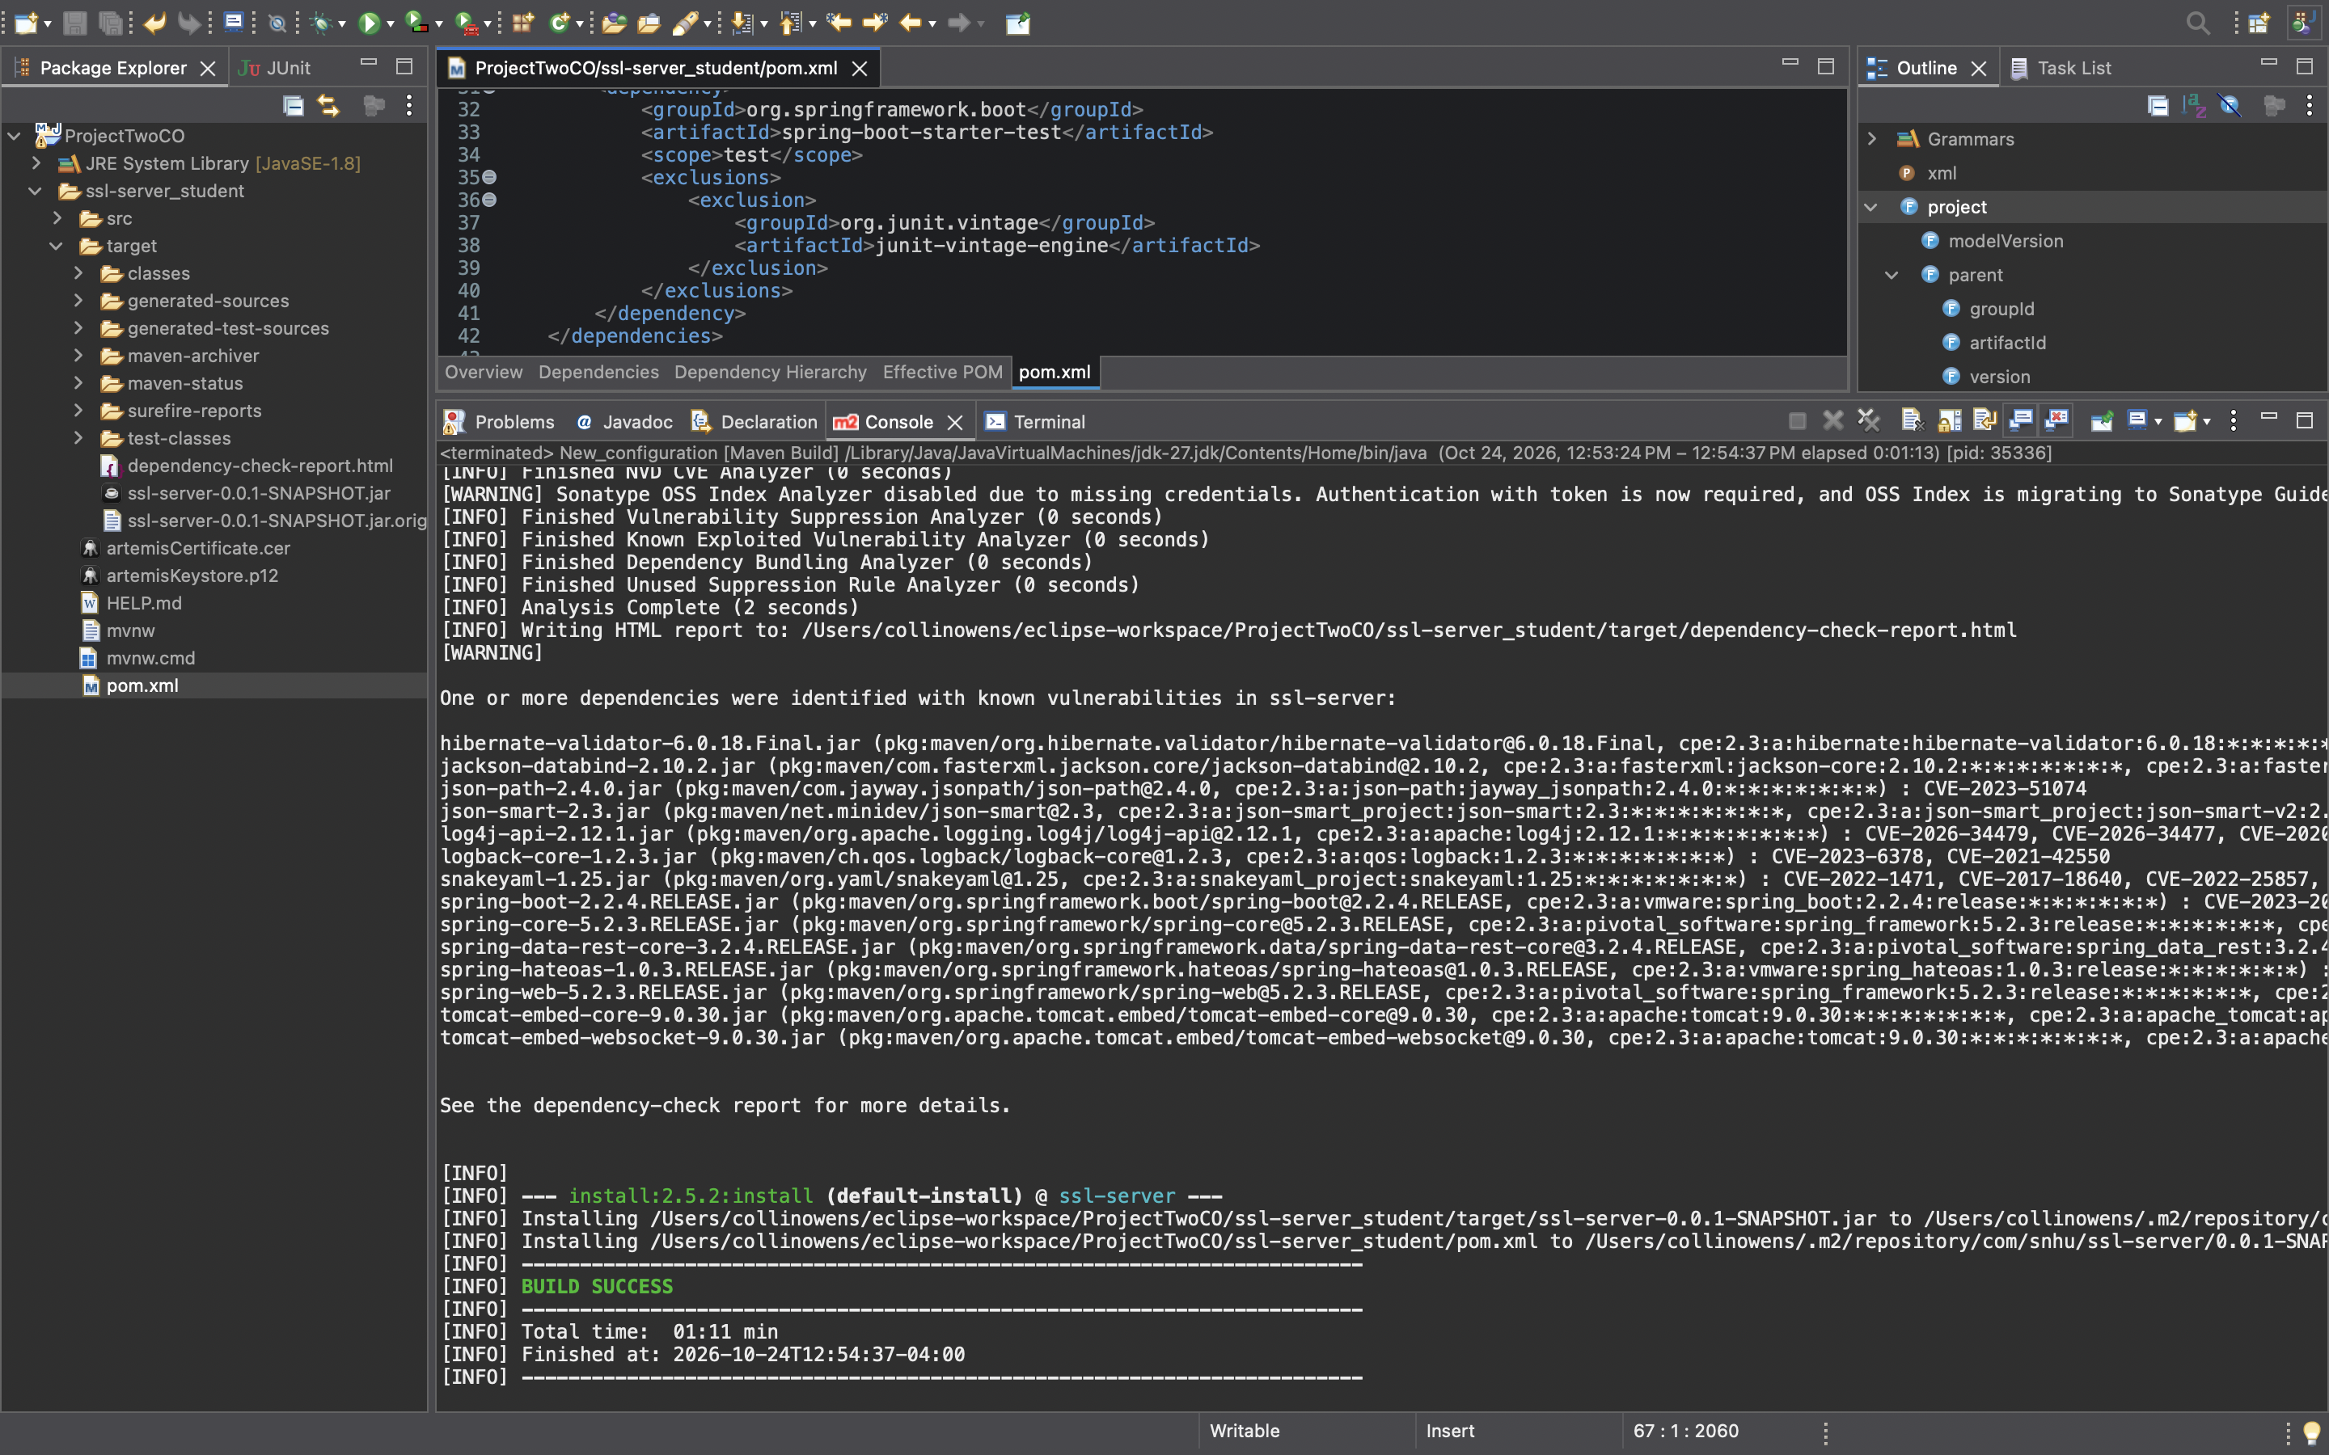
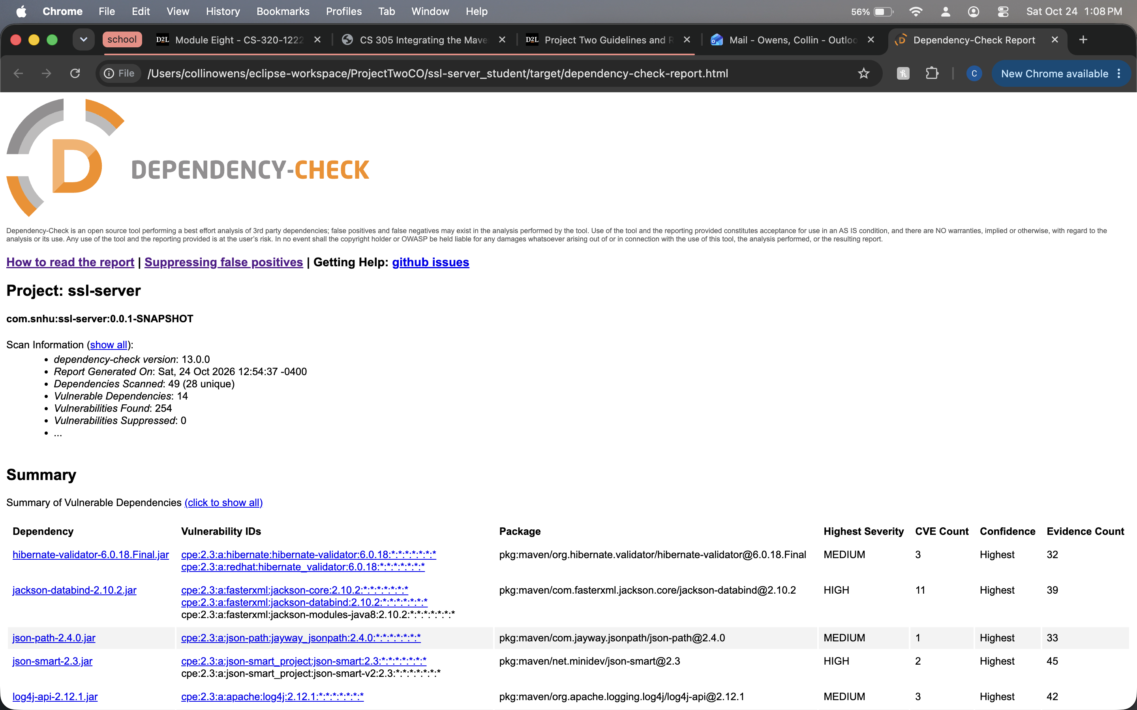

Functional Testing
Insert a screenshot below of the refactored code executed without errors.

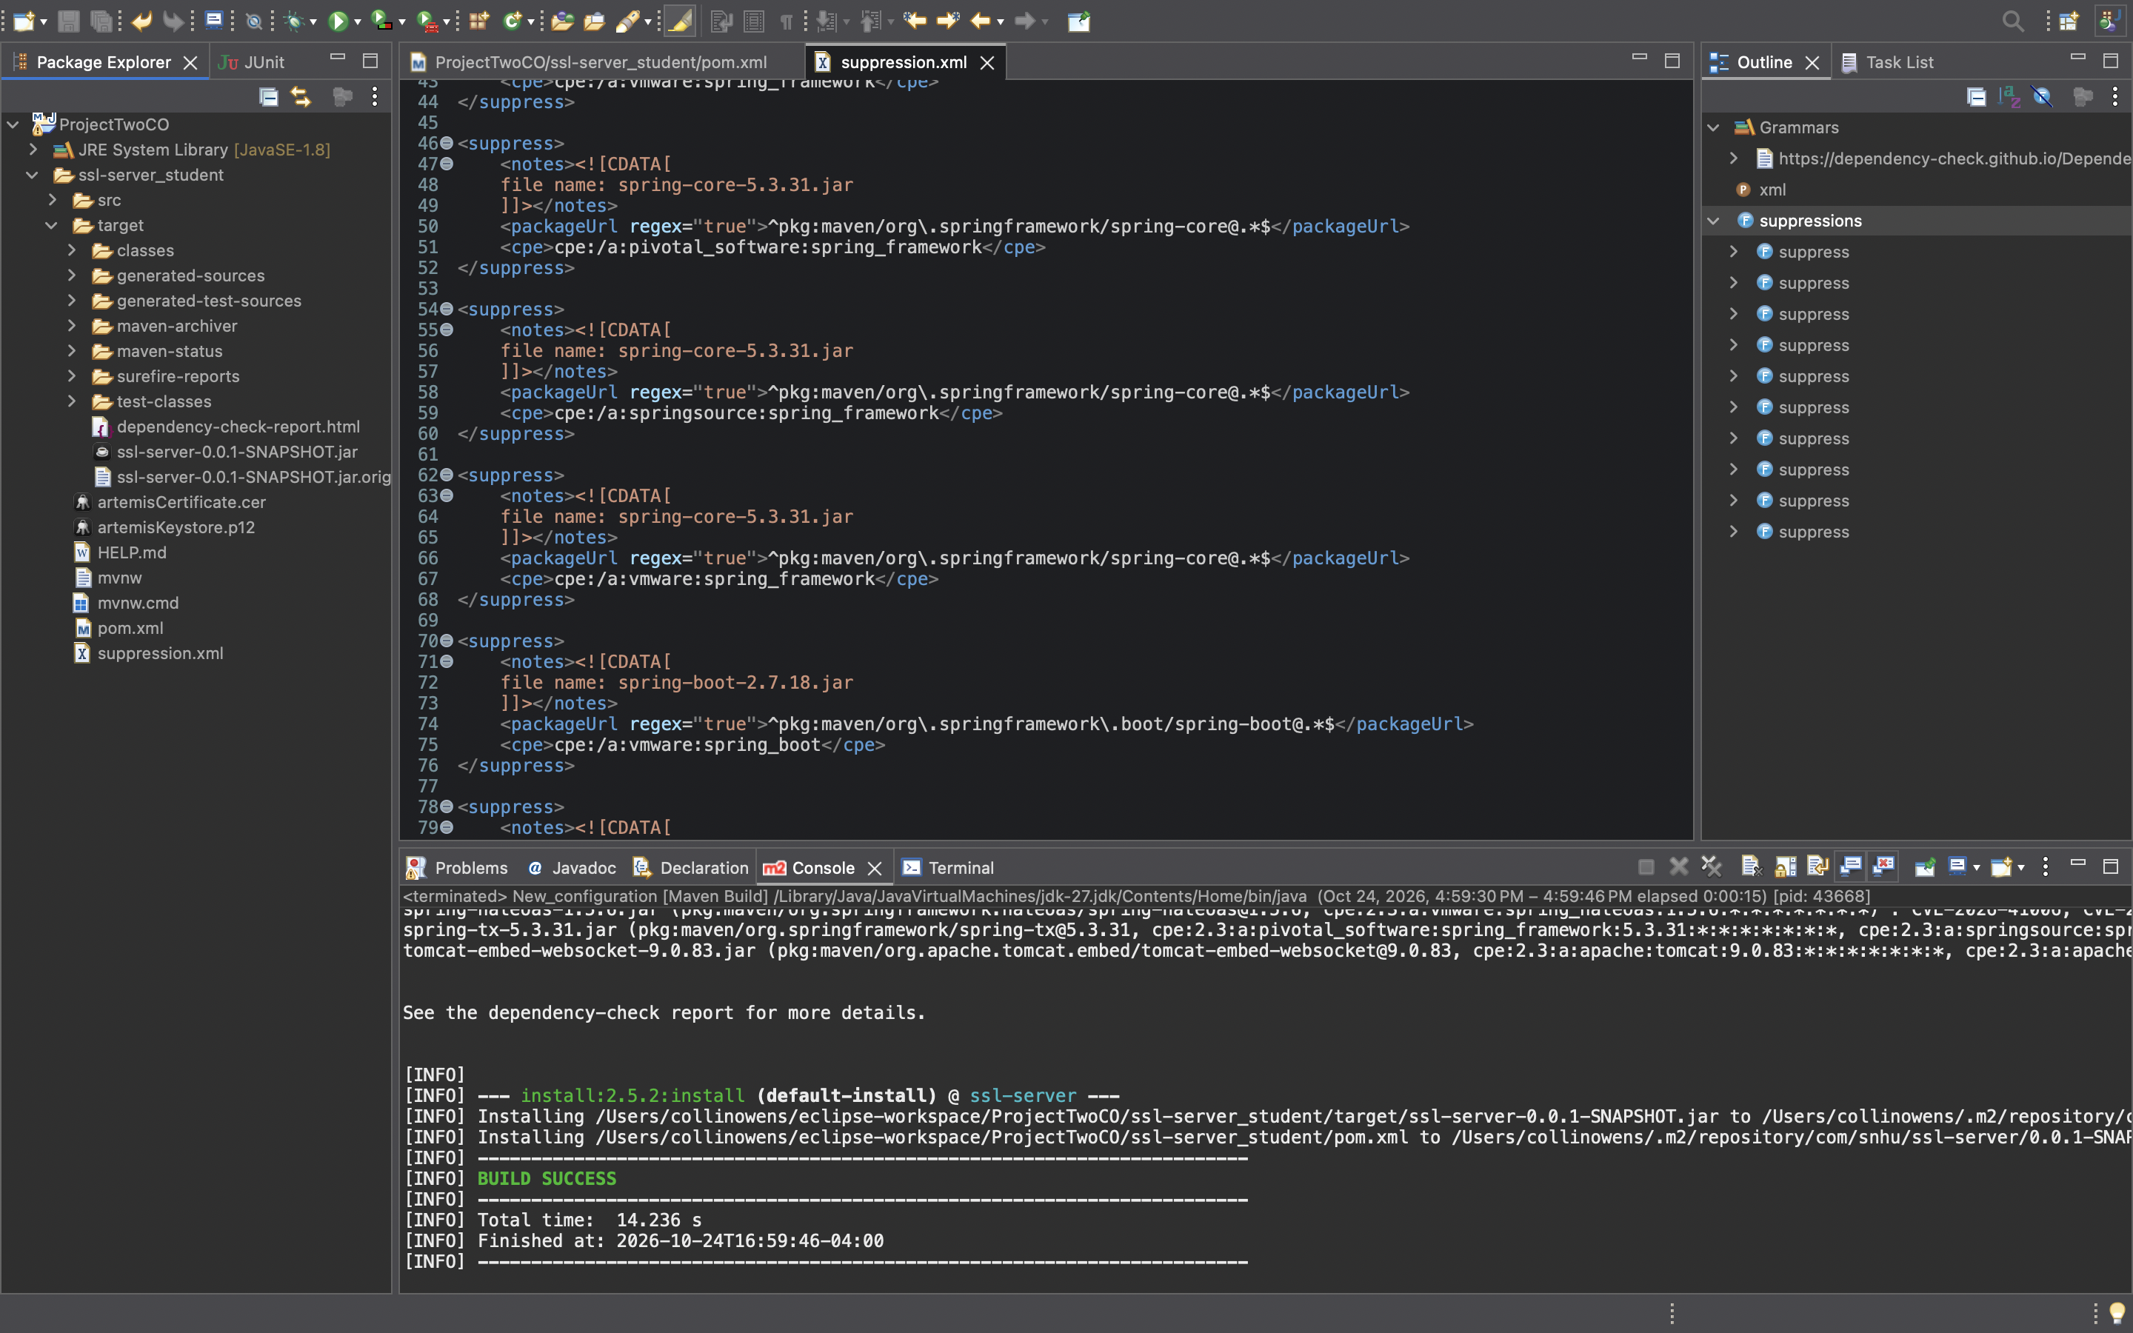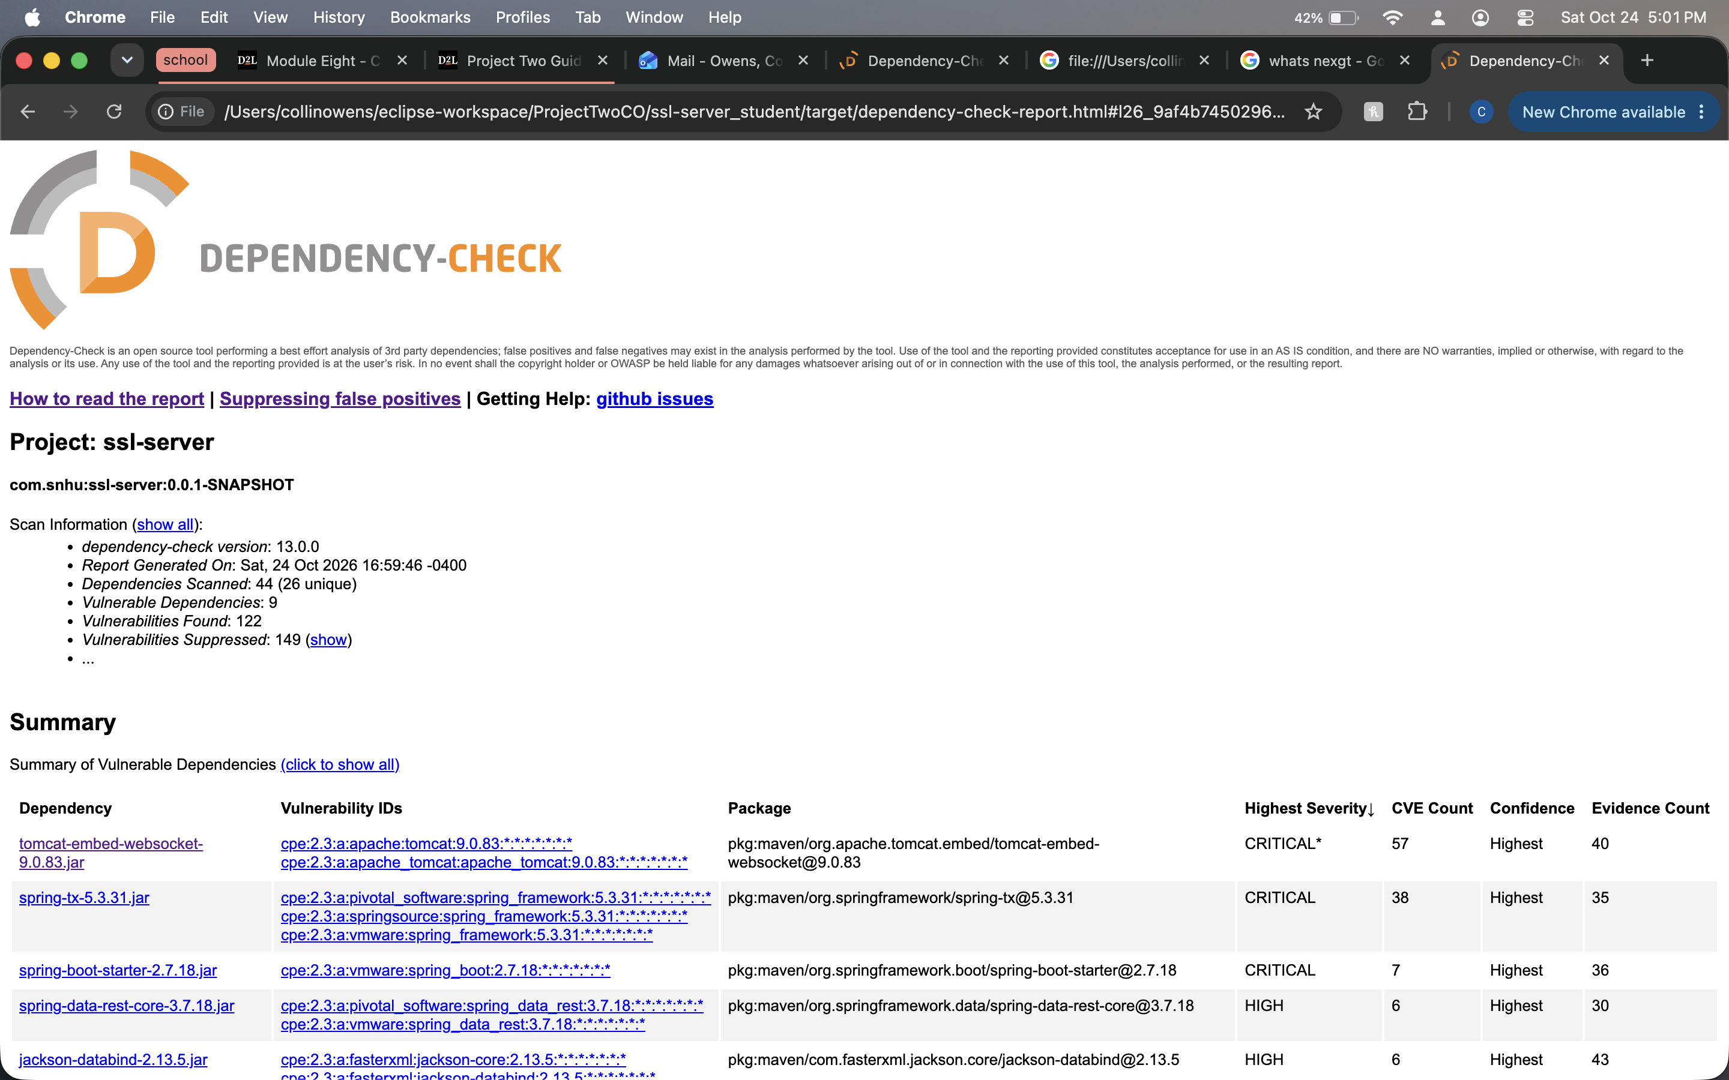

Summary

On the process flow diagram I addressed the “Client/Server & API’s” and “Cryptography & Data Integrity”. I addressed the client/server & API’s by refactoring the Maven pom.xl file. I changed the version of the spring-boot-starter-parent from 2.2.4.REALEASE to 2.7.18. That dropped the vulnerabilities down from 254 to 168. Tomcat-embed-core and the spring-web were upgraded which protected the server against RCE and DoS attacks. Cryptography & Data Integrity was addressed also by updating the version in the spring boot. This updated the Jackson-databind and snakeyaml vulnerabilities mitigating the risk of data moving through the client server being manipulated.
I added layers of security by running the dependency check. This allowed me to run a static analysis against the codebase while using the National Vulnerability Database to show hidden security vulnerabilities. I then suppressed certain vulnerabilities that are not needed.

Industry Standard Best Practices

I used a few techniques to implement industry standard best practices. One of them was using the OWASP Dependency check and comparing the code against the National Vulnerability Database. This made the audit process much faster and accurate since it was not a manual audit. Another way was upgrading the version to ensure compliance. In doing so I was able to eliminate a few critical vulnerabilities. The third technique I did was creating a suppression.xml file to make the dependency check easier to read and hide the false positives.

